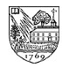
DARTMOUTH CLUB OF EASTERN FAIRFIELD COUNTY, INC.
Serving Danbury, Easton, Fairfield, Milford, Monroe, Redding, Shelton, Stratford,
Southport, Trumbull, and Bridgeport, where the club was founded circa 1924.
Website: www.dartmouth.org/clubs/dcefc

UPCOMING EVENTS April 2011

Date: Event: Contact Email: Phone:
Friday, May 13 DCEFC Annual Dinner burbine@alum.dartmouth.org 254-9331
Saturday, June 25 Big Green Bus burbine@alum.dartmouth.org 254-9331
Sunday, Aug.? (TBD) Bridgeport Bluefish burbine@alum.dartmouth.org 254-9331
Sunday, Sept.? (TBD) Lake Mohegan Walk/Hike burbine@alum.dartmouth.org 254-9331
Sunday, Dec. 4 DCEFC Holiday Party burbine@alum.dartmouth.org 254-9331

Be sure to check out our web site (http://www.dartmouth.org/clubs/dcefc/) for updates!

Save the Date for the Annual Dinner!

The annual dinner will be held on Friday, May 13 at Birchwood Country Club in Westport (25 Kings Highway South, Westport CT 06880), with cocktails (cash bar) starting at 6:00p.m. and dinner at 6:45p.m. RSVP by May 6 to Sara Potter using the enclosed response form. Cost is $50 per person. Directions: https://birchwoodcc.memberstatements.com/tour/tours.cfm?tourid=63388

The Big Green Bus comes to Fairfield!
On Saturday, June 25, Dartmouth’s Big Green Bus will be visiting Fairfield, parking at Sherman Green for the afternoon as part of the 2011 summer tour. If you are not familiar with the Big Green Bus, it is an ongoing project to promote awareness and enthusiasm for energy sustainability. The group currently includes 13 Dartmouth College students who will be traveling the country on their 1989 MCI coach bus which has been converted to run on waste vegetable oil and outfitted with solar panels. http://www.thebiggreenbus.org/

Monthly Luncheons

DCEFC monthly luncheons are held on the third Wednesday of every month. Upcoming dates: May 18 and June 15. Future locations to be determined (recently the group has been at the Fairfield County Hunt Club, 174 Long Lots Road, Westport). Check with Bob to find out the current location. Reservations VERY strongly recommended in advance but at least by 5:15 p.m. the day before by calling Bob Johnson '59 at 259-5323 or e-mail at Thejohnsons2@aol.com.

Local Dartmouth Sports Schedule (www.dartmouth.edu/athletics)
Sport Date Opponent/Tournament Location Time
Track & Field May 7-8 Heptagonals New Haven, CT TBA

RECENT EVENTS

Holiday Party!

About 40 people gathered at the home of Kathy and Russ Mitchell on December 12th to celebrate the holiday season Dartmouth style. Adults and children alike enjoyed the good food and good company, and the Mitchell’s brought in “expert” chefs to bring us freshly baked pizza from their awesome pizza oven. The Dartmouth Decibelles provided the entertainment, singing a combination of holiday and Dartmouth tunes, and we all enjoyed chatting with the current students to hear about current life on campus. Many thanks to Kathy and Russ for once again opening their home to us!

Dartmouth Entrepreneurial Network Event
On April 6, the DCEFC co-sponsored an event with the Dartmouth Entrepreneurial Network of CT call “Mapping out Buried Treasures in the Marketplace” in New Haven CT. About 40 alumni from New Haven and Fairfield counties attended the event to network and to hear the three main speakers discuss their entrepreneurial experiences.

President Kim Visits Fairfield County

President Jim Yong Kim came to Stamford CT on December 7th to greet an overflow crowd of Dartmouth alumni. The event drew alumni from all over Fairfield County (and beyond), and President Kim gave a great presentation of his ideas for preserving Dartmouth’s rich traditions while still keeping the College at the cutting edge of technology and thought leadership. Several members of the DCEFC were in attendance.

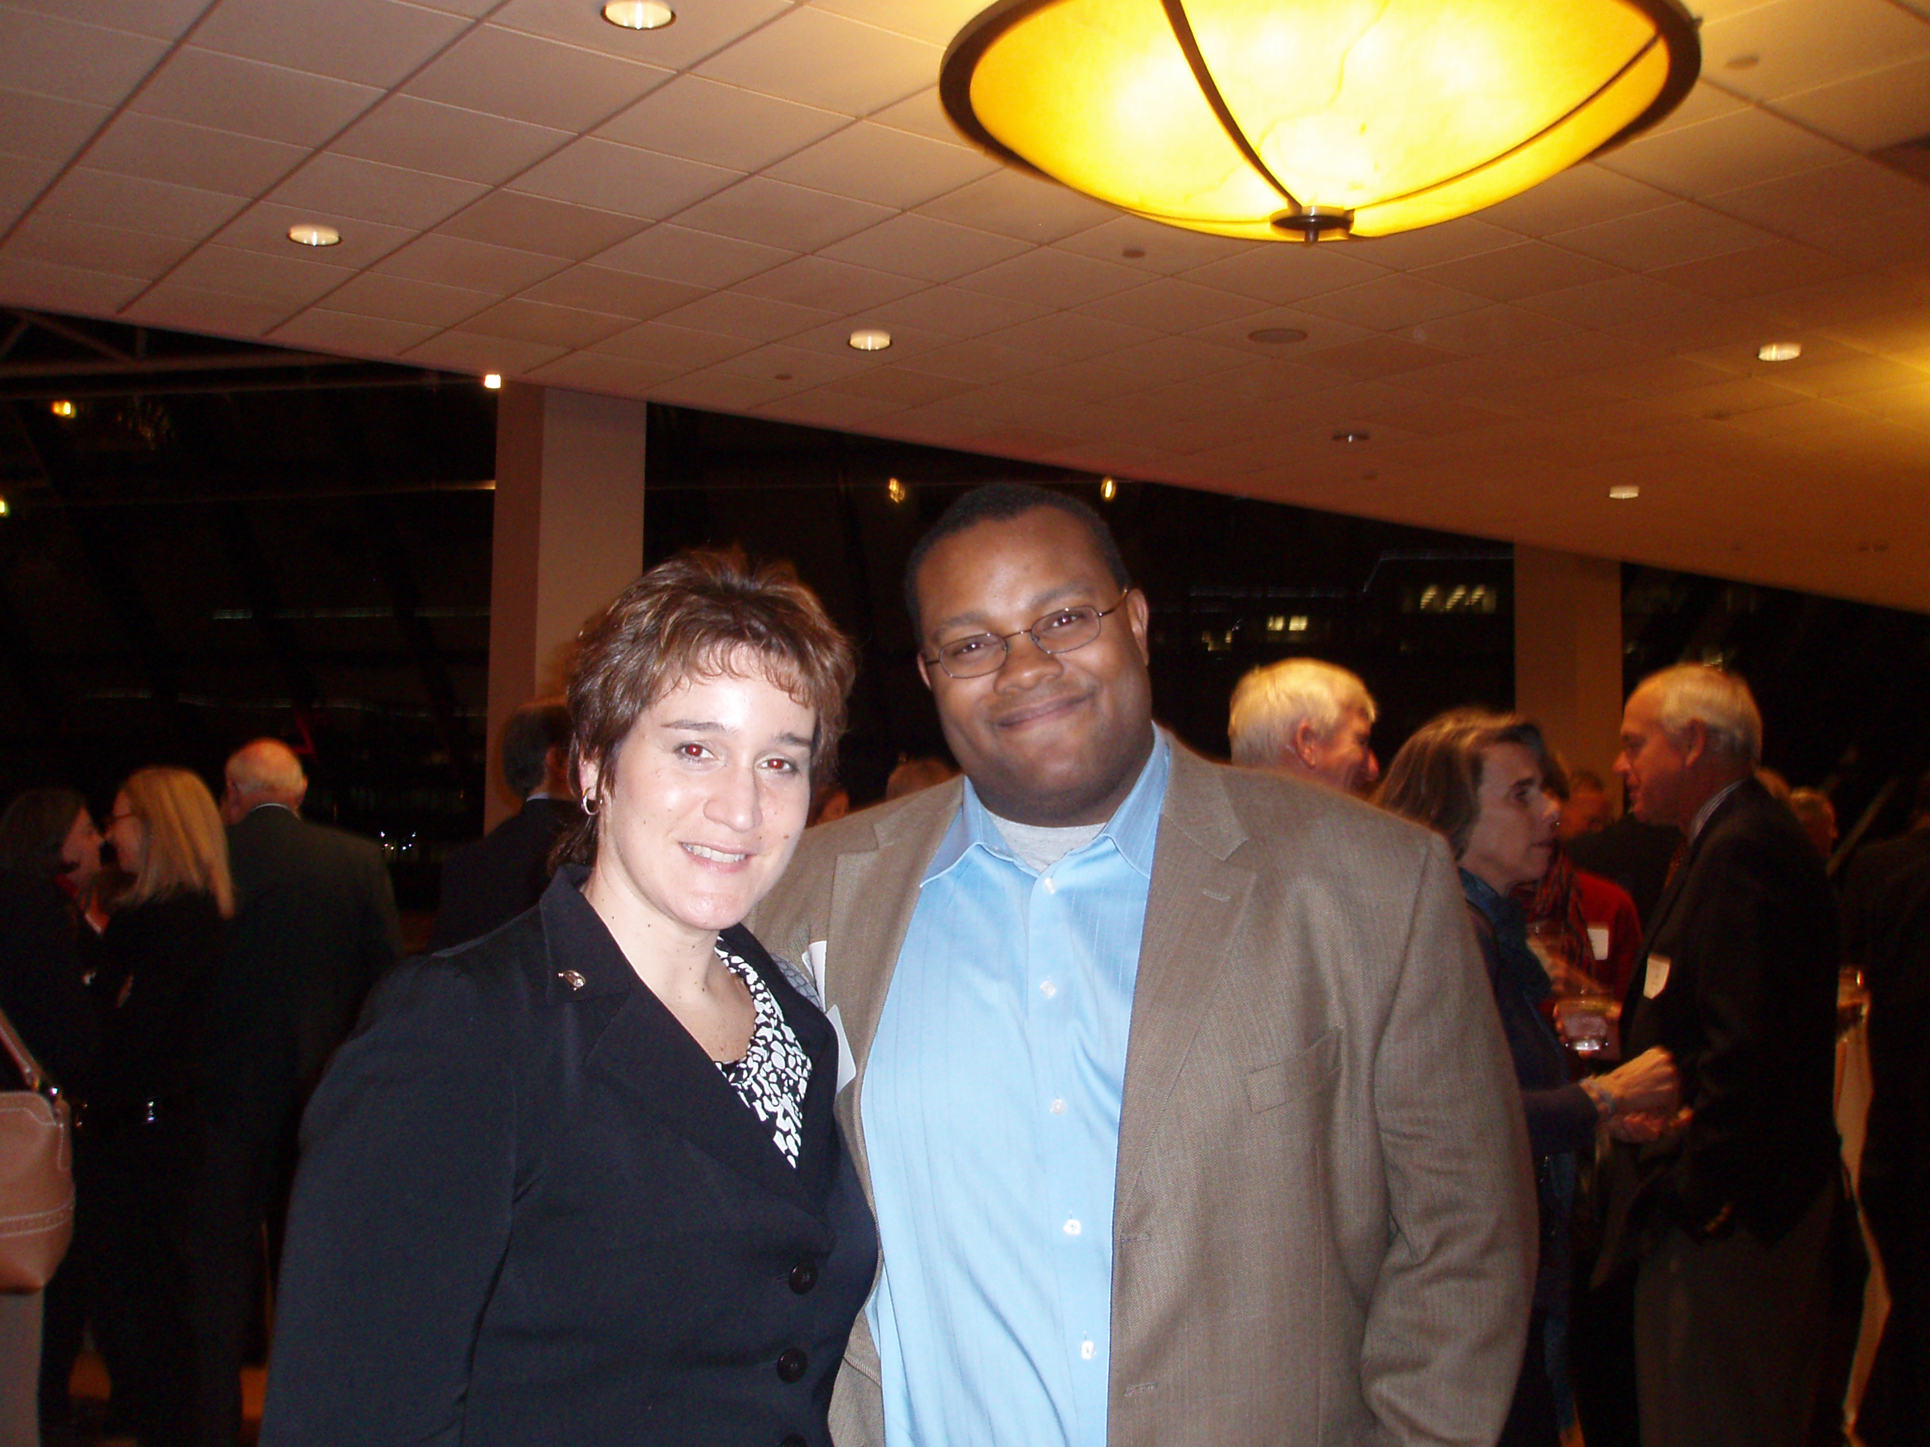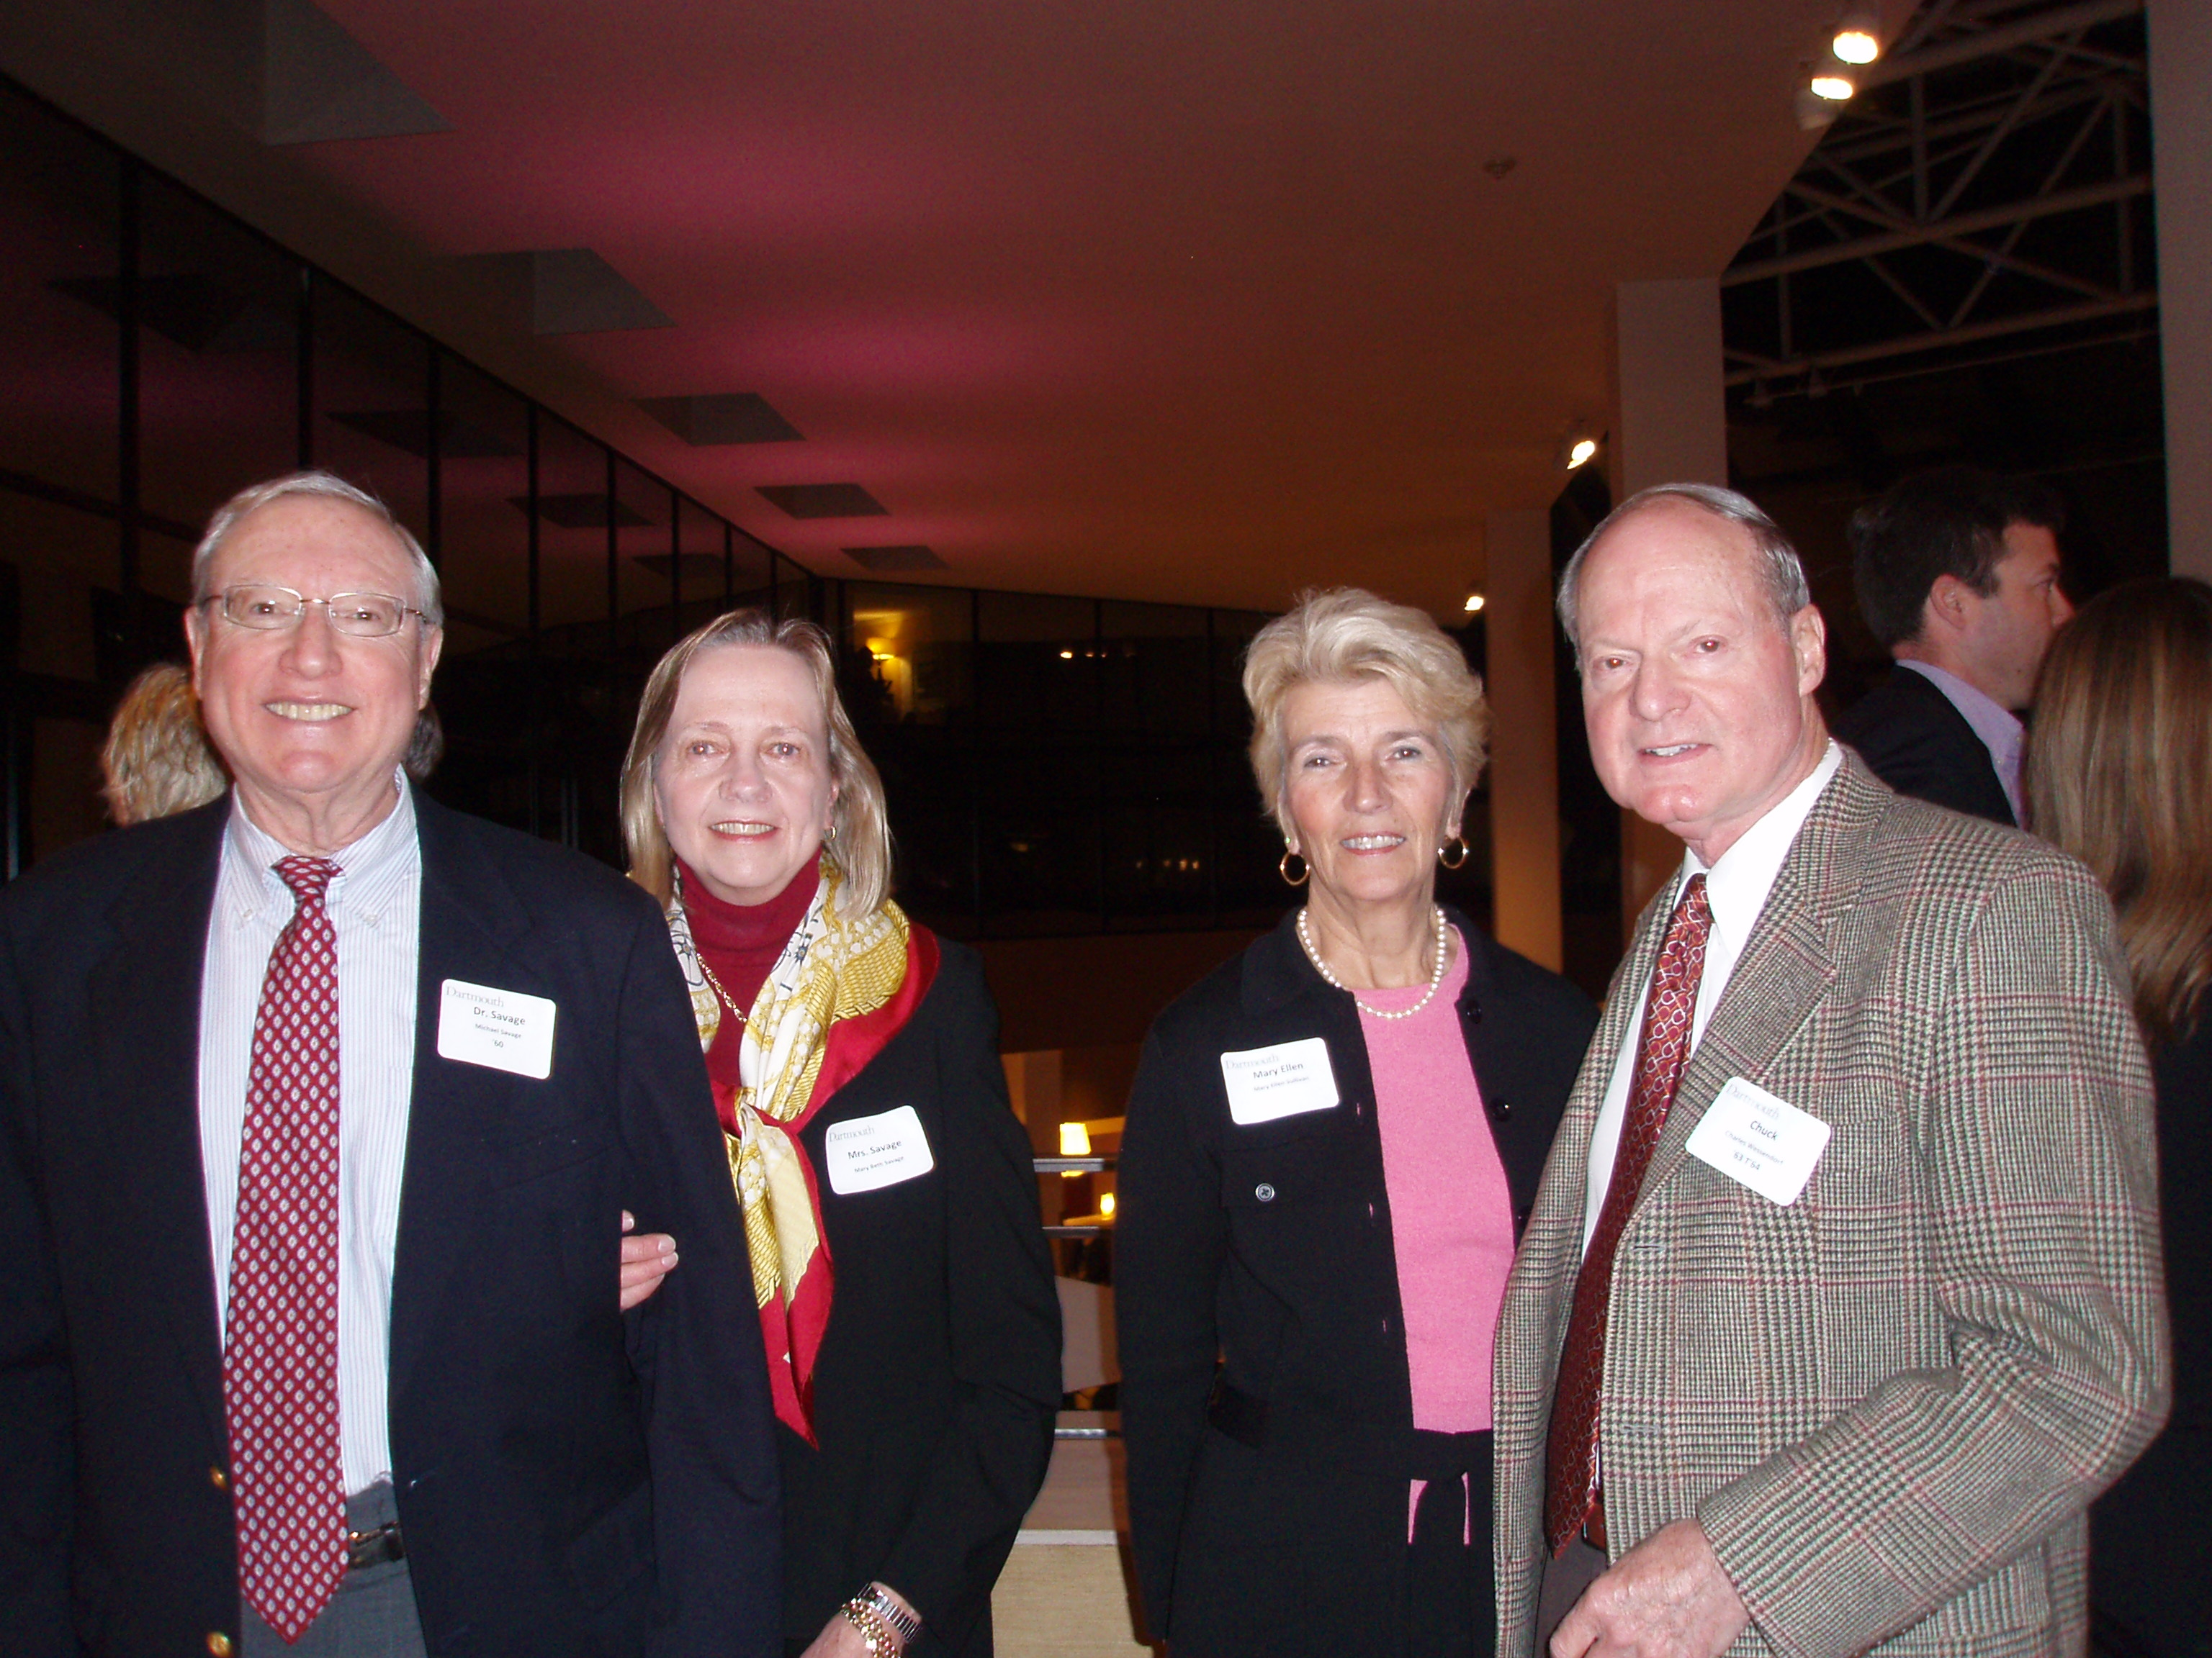
Sara Potter and Eric Jenkins Mark and Mary Beth Savage, Mary Ellen Sullivan, Chuck Wessendorf

CLUB NEWS

Acceptances to the Class of 2015

We had a terrific outcome for our district this year! Our district had a record 78 applications (a 70% increase from last year!) applicants for the class of 2015, with three students admitted Early Decision and five admitted through the Regular Decision process. This makes our district’s acceptance rate 10.3%, versus the 9.7% overall average for Dartmouth. Here they are:

Name Town High School
Nicole Boyd Monroe Masuk High School (RD)
Emma Gleeman Fairfield Hopkins School (RD)
Maxwell Gottschall Trumbull Trumbull High School (RD)
Hayley Lynch Southport Fairfield Ludlowe High School (ED)
Jamie Mercado Fairfield Fairfield Warde High School (ED)
Taylor Peterson Fairfield Fairfield Ludlowe High School (RD)
Omar Sobh Shelton Shelton High School (RD)
Sarah Whittaker Fairfield Greens Farms Academy (ED)

Thanks to our DED Gabrielle Guise and her hard-working team of interviewers, we were able to interview 100% of the candidates from our district. Given the increasingly large number of local applicants every year, we can always use more volunteers to help out with alumni interviews. Gabrielle would be happy to give you some pointers, and there is great information available on the College web site (http://www.dartmouth.edu/~interviewers/interviewing/index.html). If you are interested in participating in alumni interviews next year, please contact Gabrielle. (gabrielle.guise@yale.edu or 256-1558).

FARE Update

We continue to sponsor our college book scholarships for Bridgeport public high school students through the Bridgeport Public Education Fund. We are currently sponsoring six local students. This year, we expect to renew those scholarships, and to give awards to three additional graduating seniors. If you are interested in mentoring one of these students as they get their educations, contact Sara Potter.
Election of Club Officers

We will be electing the new slate of officers at the annual dinner. For your convenience, a voting proxy is included on the same page with your annual dinner response form. The voting is for dues-paying members of the club only, so if you haven’t paid your dues yet, you can use the same form to do that! Below is the roster of officers whose terms expire on May 13. Thanks to everyone who served the club this past year!

President Eric Jenkins ’99 jenkine@gmail.com
2nd VP Nicole Schmidt ‘94 nickyschmidt@gmail.com
Secretary Deb Karazin Owens ’91 djowens@optonline.net
Treasurer, Newsletter Editor Sara Burbine Potter '91 burbine@alum.dartmouth.org
At Large Suzy Nachman Mercado '86 mercman@optonline.net
At Large Kathy Mitchell '83 kathym@mitchellsonline.com
At Large Steve Hafner '91 shafner@kayak.com
Continuing Ed Joel Goldfield '76 joel@cs.fairfield.edu

Dues Honor Roll

These club members have already paid their dues for the current dues year. Your dues help pay for this newsletter and other club programs, so they are greatly appreciated. If you have not yet paid your dues, please use the dues form on the last page of this newsletter.

Name Class Town Class Class Town

Beverly Abt 56W Southport
Dorothy Baekey 56W Fairfield
Alice Becker 48W Southport
Jim Biggs 63 Southport
Jean Bowler 51W Fairfield
Margaret Cole 51W Fairfield
Milton Cooper 46 Easton
Clifford Ennico 75 Fairfield
James Gardner 69 Fairfield
Joel Goldfield 76 Fairfield
Raymond Jankowich 52 Stratford
Adrienne Jenkins 97 Milford
Eric Jenkins 99 Milford
Bob Johnson 59 Fairfield
Nancy Lomazzo 87 Old Greenwich
Suzy Mercado 86 Fairfield
Hoby Millington 60 Fairfield
Kathy Mitchell 83 Fairfield
W. Bradley Morehouse 46 Fairfield
Carl Nelson 59 Fairfield
Sara Burbine Potter 91 Fairfield
Robert Shannon 51 Stratford
Alicia Lacovara Soto DMS98 Fairfield
Leland Soto DMS98 Fairfield
Ken Weinstein 83 Easton

COLLEGE NEWS

Dartmouth College to Host Republican Presidential Debate in October 2011
Once again, Dartmouth College will be center stage for the next U.S. presidential race. On October 11, 2011, Dartmouth co-hosts the Republican presidential debate with the U.S. economy as the focus. The event will be broadcast nationally and around the globe by Bloomberg Television and streamed online by Washingtonpostlive.com. Broadcast journalist Charlie Rose will moderate the debate, which will be the first of the 2012 presidential campaign devoted to the single subject of the U.S. economy.

Results of Trustee Election
The Dartmouth College Board of Trustees has elected Gail Koziara Boudreaux ’82 and Bill Burgess ’81 as new members of the board following a nomination vote by Dartmouth's alumni. They both will join the board on June 12, following Commencement ceremonies.

Dartmouth Admits 9.7 Percent of Applicants for Class of 2015
Once again, Dartmouth experienced a record number of applicants for the class of 2015. A record 22,385 applications were processed, with admission offered to 2,178 students, or 9.7 percent of the applicant pool. This includes the 444 students admitted through the early decision process. In 2010, the rate of admission was 11.5 percent. The projected enrollment for the Class of 2015 will be approximately 1,100.
Reservation for DCEFC Annual Dinner, Friday, May 13, 2011

I am looking forward to a great evening! I would like to reserve the following number of places:

1 2 3 4 Dinner(s) @ $50 = $_________ Make checks payable to DCEFC, Inc.

Name: _____________________________________________________Class:________

Please return by May 6, 2011 to Sara Potter ’91, 108 Hillcrest Road, Fairfield CT 06824

*************************************************************************************
Dartmouth Club of Eastern Fairfield County
Proxy ballot for election of officers for 2011-2012 (members only)

President Eric Jenkins ’99 YES______ NO______ ABSTAIN______
1st VP open YES______ NO______ ABSTAIN______
2nd VP Nicole Schmidt ‘94 YES______ NO______ ABSTAIN______
Secretary Deb Karazin Owens ‘91 YES______ NO______ ABSTAIN______
Treasurer Sara Burbine Potter ‘91 YES______ NO______ ABSTAIN______
At Large Suzy Nachman Mercado '86 YES______ NO______ ABSTAIN______
At Large Kathy Mitchell '83 YES______ NO______ ABSTAIN______
At Large Steve Hafner '91 YES______ NO______ ABSTAIN______

Appointees for 2011-12:
DED: Gabrielle Guise ‘85 Newsletter: Sara Potter ‘91
Continuing Ed.: Joel Goldfield ‘76 Book Awards: Jim Gardner ‘69
Monthly Luncheon Chair: Bob Johnson ‘59

Name (print): _____________________________________________________Class:________
Signature: _______________________________________________________Date: ___/___/___

*************************************************************************************
DCEFC Dues Invoice (11/15/10-11/15/11)

$35 Classes 1995 and earlier
$25 Classes of 1996-2005
$10 Classes of 2006 and younger
$15 for widow/widower or parents
$7 for alumni spouse of duespayer

Note: Graduates of Tuck, Thayer, or Dartmouth Medical School who did not attend Dartmouth as an undergraduate pay based on the year they received their undergraduate degree from another institution.
Note: Graduates of Dartmouth, Tuck, Thayer or the Medical School who are members of the DCEFC but live outside of the Eastern Fairfield Country district pay one-half (50%) of the rate they would otherwise pay (minimum $7.50).

NAME and CLASS: ________________________________________ Dues: $ _______
STREET: _________________________________________________ Scholarship Fund _______
TOWN, STATE, ZIP: _______________________________________ Book Award _______
TEL: ____________________________________________________ Bursary Fund _______
EMAIL: __________________________________________________ TOTAL $ _______

Dues are tax deductible. Make all checks payable to DCEFC, Inc.

