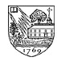 DARTMOUTH CLUB OF EASTERN FAIRFIELD COUNTY, INC.
Serving Danbury, Easton, Fairfield, Milford, Monroe, Redding, Shelton, Stratford,
Southport, Trumbull, and Bridgeport, where the club was founded circa 1924.
Website: www.dartmouth.org/clubs/dcefc

UPCOMING EVENTS November 2009

DCEFC Holiday Party

Mark your calendars now! This year the event will be held on Sunday, December 6th at the home of Kathy ’83 and Russ Mitchell ’85, 210 Cobbler's Hill Road in Fairfield. The party will run from 4:00 to 6:00 p.m., and a donation of $5 per person will be collected at the door. We will also be collecting money for our scholarship fund that night. Children are welcome. RSVP to (203) 256-1530 or kathym@mitchellsonline.com. Please bring an appetizer of your choice.

DCFC Holiday Party in Greenwich

Our friends at the Dartmouth Club of Fairfield County are including our club in their annual holiday party on Wednesday, December 16 from 7-9p.m. The party will be held at Richards of Greenwich, 359 Greenwich Avenue, Greenwich CT 06830, with a performance by the Dartmouth Aires. The cost is $25 per person for DCFC or DCEFC members, $30 for non-members, payable at the door via cash or check made out to DCFC. Includes wine and other beverages plus hors d’oeuvres. RSVP to (203) 921-9951 or DCFC@Dartmouth.org. Please include the names and number of people for your group when you RSVP.

Monthly Luncheons

DCEFC monthly luncheons are now being held at the Fairfield County Hunt Club, 174 Long Lots Road, Westport. Upcoming dates: November 18, December 16, and January 20. Reservations VERY strongly recommended in advance but at least by 5:15 p.m. the day before by calling Bob Johnson '59 at 259-5323 or e-mail at Thejohnsons2@aol.com.

Dartmouth Sports Schedule

Sport Date Opponent Location Time
Women’s Hockey Nov. 21 Yale New Haven CT 6:00 PM
Men’s Basketball Nov. 15 Quinnipiac Hamden CT 2:00 PM
Women’s Hockey Jan. 2 UCONN Storrs CT 1:00 PM
Women’s Hockey Jan. 3 UCONN Storrs CT 1:00 PM
Women’s Hockey Jan. 8 Quinnipiac Hamden CT 3:00 PM
Squash (M&W) Jan. 9 Yale New Haven CT 11:00 AM
Squash (M&W) Jan. 9 Trinity Hartford CT 5:00 PM
For information on more Dartmouth sporting events, go to www.dartmouth.edu/athletics.

RECENT EVENTS

Bridgeport Bluefish Game
Thirteen people were in attendance at the DCEFC’s 2009 outing on August 9 as the Bridgeport Bluefish took on the Lancaster Barnstormers at Harbor Yard. For once, the rain held off for the entire game, and a great time was had by all!

DCEFC Day at Beardsley Zoo

On Sunday, May 31, 17 people from the DCEFC visited Bridgeport’s Beardsley Zoo. It was a beautiful sunny day enjoyed by all despite the initial challenge of finding parking. The otters and the prairie dogs were highlights for the kids. We may have a new annual event!

Successful Annual Dinner!

The DCEFC/DCFC joint annual dinner held on May 1 at The Field Restaurant in Fairfield was a great success, thanks to guest speaker Professor Roger Ulrich ’77. Prof. Ulrich has been teaching Roman art, archaeology, and Latin at Dartmouth since 1989, and has consulted for the Department of Defense to develop training materials about fragile archaeological sites for U.S. soldiers deployed in the Middle East. Consider him Dartmouth’s own Indiana Jones. We had 42 people in attendance, including seven members of the Dartmouth class of 2013 from Fairfield County, and a great time was had by all. Photo, from left to right: Joel Goldfield, Prof. Ulrich, and Imogen Ulrich.

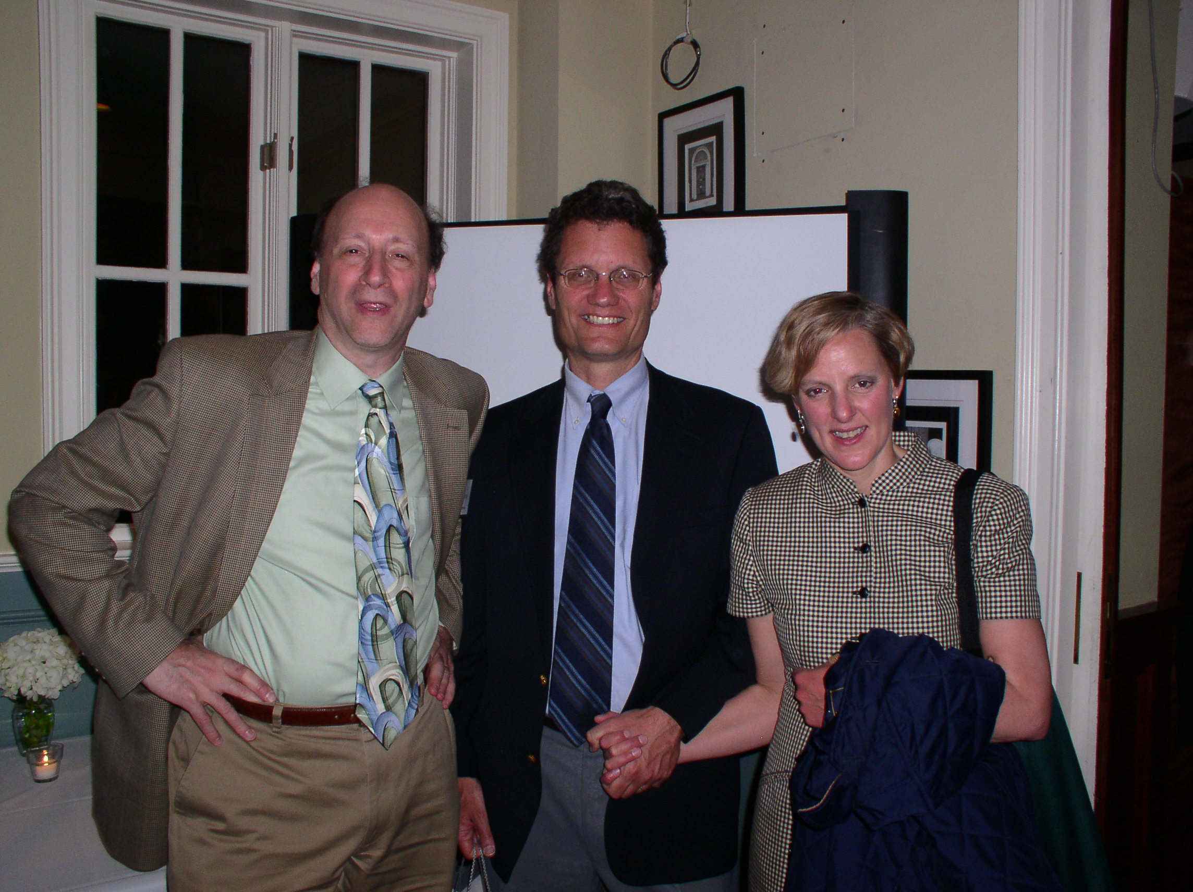

Lake Mohegan Walk/Hike

On Sunday, April 26, seven people and one dog enjoyed a fun stroll around Lake Mohegan in Fairfield. Photo, from left to right: Deb Owens, Jeff Owens, Jack Owens, Katie Owens, Sara Potter, Arlene Johnson and Kurt Potter. And our mascot Lucky Owens in the front!
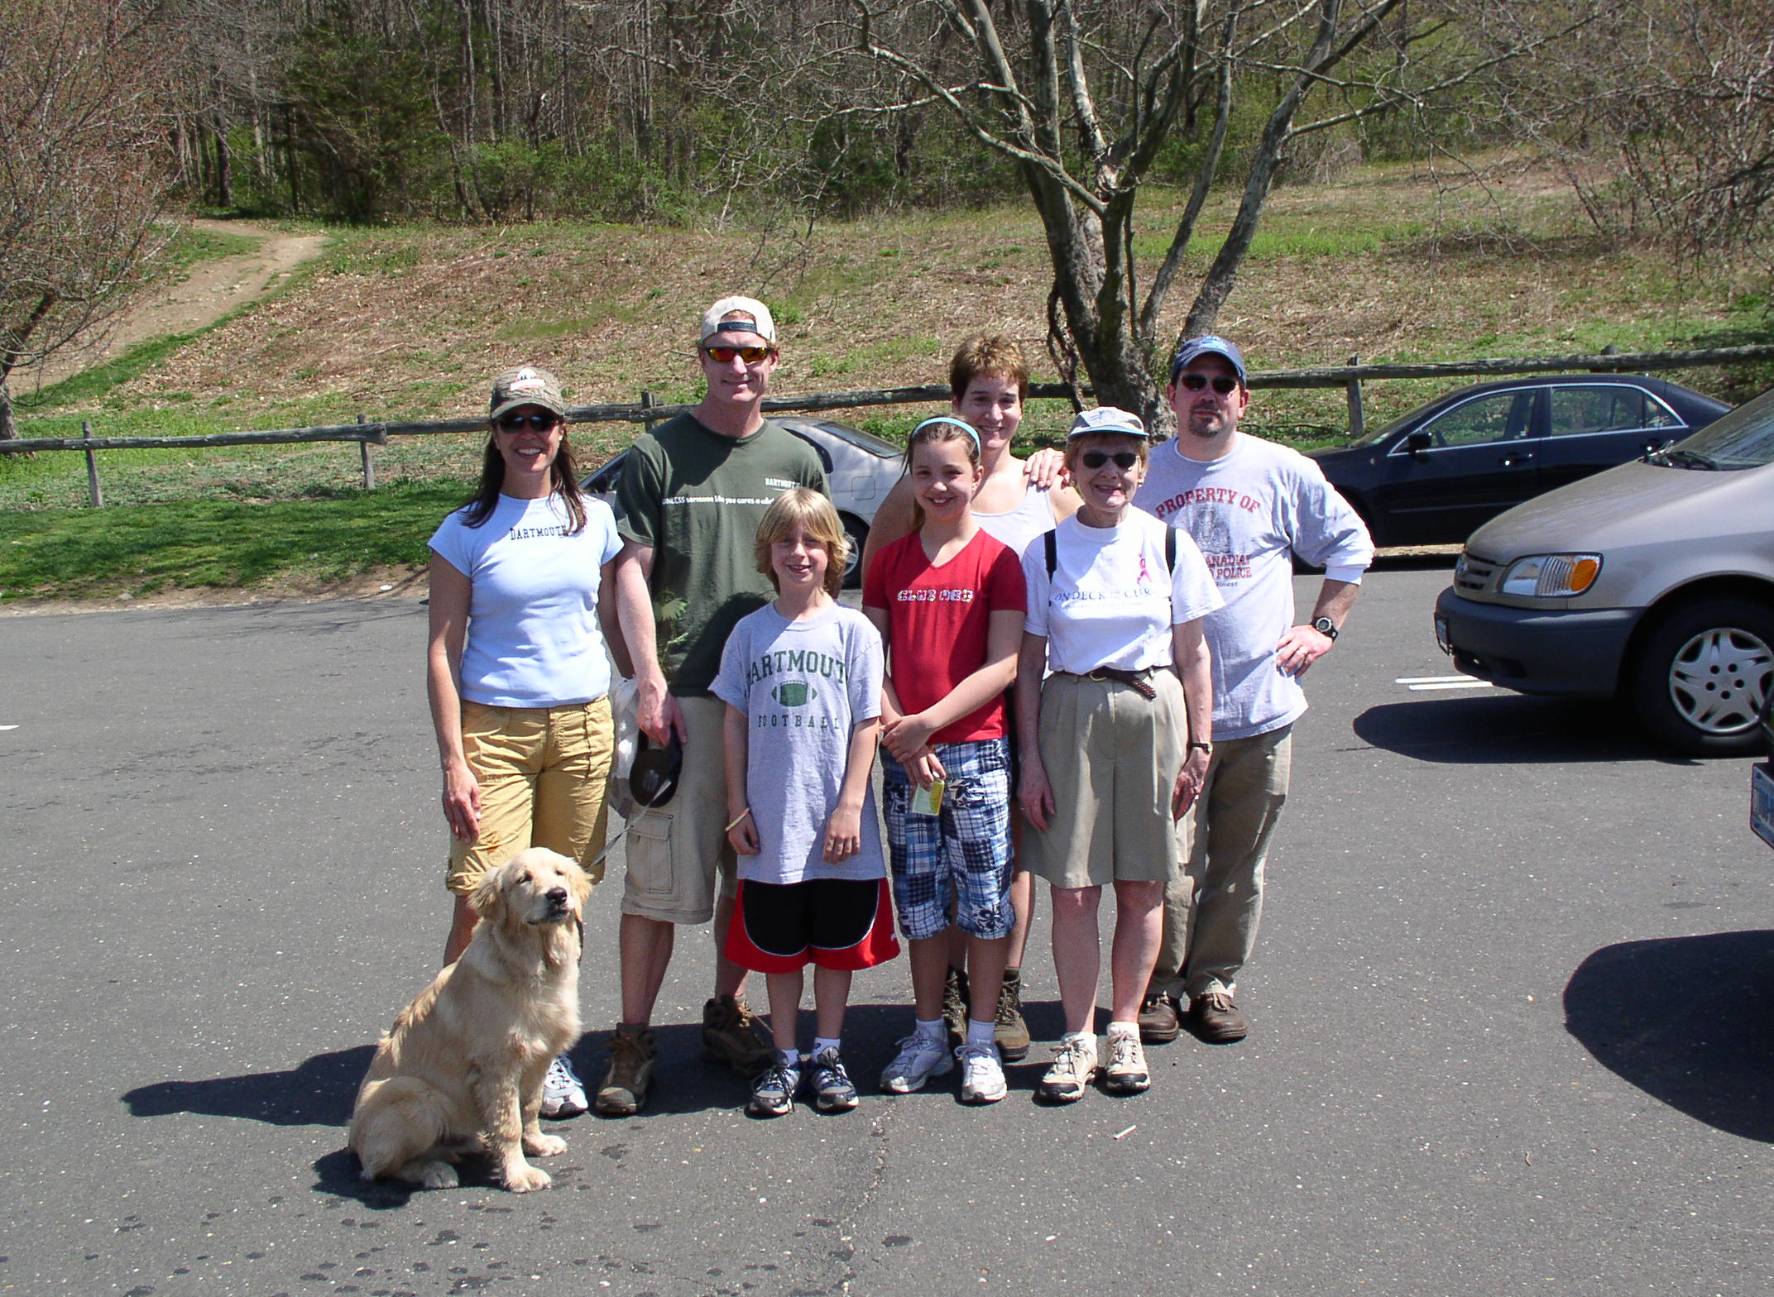

CLUB NEWS

Dartmouth Class of 2013
Our district sent the following local students up to Hanover this fall to join the Class of 2013:
Alexander Brown, Fairfield Warde High School
Anuj Gupta, Joel Barlowe High School
Helena Witte, St. Luke's School

This year, admissions once again set new records, with Dartmouth College receiving its largest-ever number of applications for the class entering the college fall of 2009, and accepting its lowest-ever percentage of applicants. Congratulations to the outstanding students accepted from our district and many thanks to all who participated in the interview process.
DCEFC Book Award Recipients
Winner School Town
Derek Chhiv Masuk High School Monroe
Michael Doran Jonathan Law High School Milford
Sarah Frassetto St. Joseph High School Trumbull
Maxwell J. Freccia Fairfield Prepatory School Fairfield
Michael Galant Trumbull High School Trumbull
Rachel Hannibal Christian Heritage School Trumbull
Nhathalie Jean-Baptiste Bassick High School Bridgeport
Kate Kaminski Canterbury School New Milford
Kathleen Maffei Fairfield Ludlowe High School Fairfield
Daniel Ming Fairfield Warde High School Fairfield
Mary Mohyde Bunnell High School Stratford
Patrick Murphy Joel Barlow High School West Redding
Amanda Rodrigues Lauralton Hall, Academy of Our Lady of Mercy Milford
Anthony Russo Stratford High School Stratford
Dipanjan Saha New Milford High School New Milford
Alec Tutino Joseph A Foran High School Milford

FARE Book Scholarships
The DCEFC continued our work with the Bridgeport Public Education Fund (BPEF) to sponsor $500 college book scholarships for students graduating from one of Bridgeport’s three public high schools. The scholarships are renewable for up to 3 years, and are awarded to students participating in the BPEF’s MAACS program, Mentoring for Academic Achievement and College Success. A scholarship will be awarded to any student in MAACS who will be attending Dartmouth College; otherwise, the students are selected on the basis of their scholarship applications.

This year, the DCEFC board had a hard time narrowing the pool to just three recipients, so we selected four. This year’s recipients are (including last year’s winners):

Name High School College Attending 1st Year
Ricardo Aldophe Bassick High School UCONN 2009
Tamara Jackson Warren Harding High School Johnson & Wales 2009
Walid Namane Central High School UCONN 2009
Latoya Radway Central High School UCONN 2009
Shanee Brown Warren Harding High School Dartmouth College 2008
Gabriela Solis Central High School UCONN – Storrs 2008
Ahmad Wahib Bassick High School University of Bridgeport 2008

2009-2010 Club Officers
President, Continuing Ed Joel Goldfield '76 joel@cs.fairfield.edu
1st VP Eric Jenkins ’99 jenkine@gmail.com
2nd VP Natalie Herring ’95 nherring@reachprep.org
Secretary Deb Karazin Owens ’91 djowens@optonline.net
Treasurer, Newsletter Editor Sara Burbine Potter '91 sara_burbine@yahoo.com
At Large Steve Hafner '91 shafner@kayak.com
At Large Suzy Nachman Mercado '86 mercman@optonline.net
At Large Kathy Mitchell '83 kathym@mitchellsonline.com
DED Gabrielle Guise ’85 gabrielle.guise@yale.edu
Book Awards Jim Gardner ’69 lonepine9@aol.com
Monthly Luncheon Chair Bob Johnson ’59 thejohnsons2@aol.com

VOLUNTEERING

Alumni Interviewers
As you all know, every applicant to Dartmouth is given an alumni interview. We can always use more volunteers to help out—it doesn’t require a big time commitment, and it is a great way to give back to the College. Anyone interested in participating in alumni interviews please contact our District Enrollment Director, Gabrielle Guise. (gabrielle.guise@yale.edu or 256-1558).

COLLEGE NEWS

Dartmouth’s New President Takes Office
On September 22, 2009, Jim Yong Kim, M.D., Ph.D. was inaugurated as the 17th President of Dartmouth. Dr. Kim is the first Asian American president of an ivy league school. For more information about Dr. Kim’s inauguration, go to http://www.dartmouth.edu/~president/inauguration/.

Keep Up with the Daily D
Really want to know what’s happening on campus? Check out The Dartmouth online at www.thedartmouth.com

DUES! DUES! DUES!

The Club’s dues year begins on November 15, so it’s that time again! Use the form below to submit your dues. Your dues help to pay for this newsletter, so they are appreciated!

Sara Burbine Potter ‘91
burbine@alum.dartmouth.org

DCEFC Dues Invoice (11/15/09-11/15/10)

$35 Classes 1994 and earlier
$25 Classes of 1995-2004
$10 Classes of 2005 and younger
$15 for widow/widower or parents
$7 for alumni spouse of duespayer

Note: Graduates of Tuck, Thayer, or Dartmouth Medical School who did not attend Dartmouth as an undergraduate pay based on the year they received their undergraduate degree from another institution.

NAME and CLASS: ________________________________________ Dues: $ _______
STREET: _________________________________________________ Scholarship Fund _______
TOWN, STATE, ZIP: _______________________________________ Book Award _______
TEL: ____________________________________________________ Bursary Fund _______
EMAIL: __________________________________________________ TOTAL $ _______

Dues are tax deductible. Make all checks payable to DCEFC, Inc.

Return to:
Sara Potter ‘91
108 Hillcrest Road
Fairfield CT 06824

